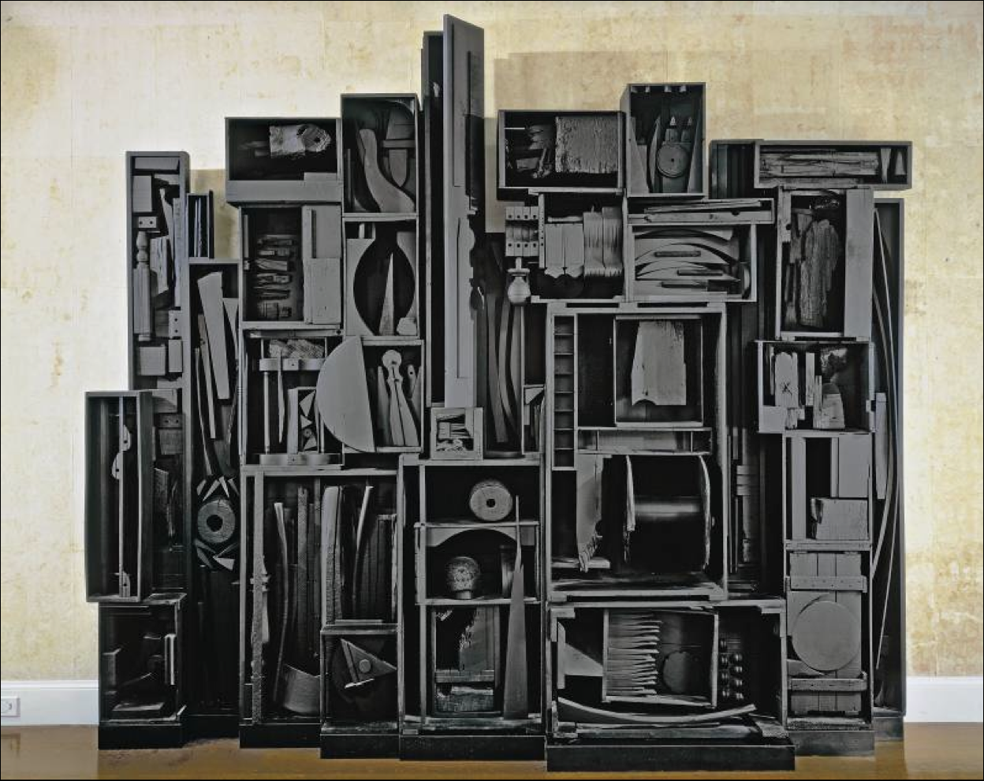

Louise Nevelson
Found Object Art

Second grade students talked about what they noticed about a sculpture by Louise Nevelson.

Everyone brought an object or chose an object to add to their group’s sculpture.

Students decided where to place their object and glued it to the artwork.

Classes voted on what color to paint their finished Found Object Art.

